EGG HARBOR TOWNSHIP
8th ANNUAL OVERIAN CANCER Sep 21 & 22, 2019
Tournament Registration Form
CONTACT INFORMATION

Team Name_____________________________________________________________________
Coach or Managers Name__________________________________________________________
Address:________________________________________________________________________
City _________________________________State ____________ Zip Code _________________
Home Phone _________________________________ Cell Phone _________________________
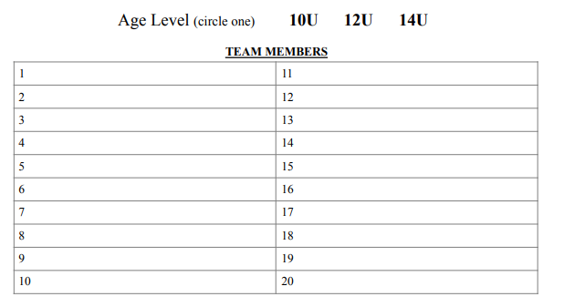
E-mail address __________________________________________________________
16U 18U

PAYMENT AND REGISTRATION
Please make sure to fill in the appropriate team member sections above.
Please return this registration with money order or check made payable to Egg Harbor Township Youth
Softball (EHTYS). The fee is $575.00 10U-14U and $675.00 16U & 18U. All registrations are accepted on a space available basis. Payments are not refundable unless tournament is cancelled by EHTYS

Please send your registration and payment to Egg Harbor Township Youth Softball, PO Box 1702,
Pleasantville, NJ 08232. For more information send an email to EHTSOFTBALL@AOL.COM

All teams are required to bring proof of Insurance and copy of birth certificates to prove players
age if required. EHT MUST BE NAMED AS A CERTIFICATE HOLDER AND ADDITIONAL
INSURED ON THE INSURANCE. 3515 BARGAINTOWN ROAD, EHT NJ 08234

